# Using a Symmetric Matrix

**For a symmetric matrix B**

**Sigma = 3.0**

**Maximal difference between any component of Vi calculated by MINRES, and that calculated by the exact solver = 0.0009793031361265414**

**Smallest Component in V (exact) = 0.00017348606233992536**

**Median Component by magnitude in V (exact) = 0.136094458345366**

**Exitcode = 0**

**Sigma = 4.75**

**Maximal difference between any component of Vi calculated by MINRES, and that calculated by the exact solver = 0.007793463265377526**

**Smallest Component in V (exact) = 0.004839866397443618**

**Median Component by magnitude in V (exact) = 0.19191382767482684**

**Exitcode = 0**

**Sigma = 6.5**

**Maximal difference between any component of Vi calculated by MINRES, and that calculated by the exact solver = 0.006803817240875601**

**Smallest Component in V (exact) = 0.0035223245366290713**

**Median Component by magnitude in V (exact) = 0.1274001097964942**

**Exitcode = 0**

**Sigma = 8.25**

**Maximal difference between any component of Vi calculated by MINRES, and that calculated by the exact solver = 0.004171276785387826**

**Smallest Component in V (exact) = 0.001423153831048407**

**Median Component by magnitude in V (exact) = 0.11300130239663608**

**Exitcode = 0**

**Sigma = 10.0**

**Maximal difference between any component of Vi calculated by MINRES, and that calculated by the exact solver = 0.031229921028117946**

**Smallest Component in V (exact) = 0.00557310977100417**

**Median Component by magnitude in V (exact) = 0.15880882032372454**

**Exitcode = 0**

# For an asymmetric matrix created by perturbing B

**For an asymmetric matrix C = B + eta*del_B**

**Sigma = 3.0**

**Maximal difference between any component of Vi calculated by MINRES, and that calculated by the exact solver = 0.0272994307079083**

**Smallest Component in V (exact) = 0.006418145321353187**

**Median Component by magnitude in V (exact) = 0.1361996760915098**

**Exitcode = 0**

**Sigma = 4.75**

**Maximal difference between any component of Vi calculated by MINRES, and that calculated by the exact solver = 0.027128652541721504**

**Smallest Component in V (exact) = 0.0009819407305999284**

**Median Component by magnitude in V (exact) = 0.15971820554769786**

**Exitcode = 0**

**Sigma = 6.5**

**Maximal difference between any component of Vi calculated by MINRES, and that calculated by the exact solver = 0.018213040936759184**

**Smallest Component in V (exact) = 0.0005869681709712339**

**Median Component by magnitude in V (exact) = 0.12507575397453188**

**Exitcode = 0**

**Sigma = 8.25**

**Maximal difference between any component of Vi calculated by MINRES, and that calculated by the exact solver = 0.048730253613613245**

**Smallest Component in V (exact) = 0.0049411314958753075**

**Median Component by magnitude in V (exact) = 0.11462840049202377**

**Exitcode = 0**

**Sigma = 10.0**

**Maximal difference between any component of Vi calculated by MINRES, and that calculated by the exact solver = 0.17642216625954987**

**Smallest Component in V (exact) = 0.008306710301176828**

**Median Component by magnitude in V (exact) = 0.2222051110781847**

**Exitcode = 0**

# An example (Everything wrt. Asymmetric matrix C)



We calculate Vi using the exact solver and MINRES –

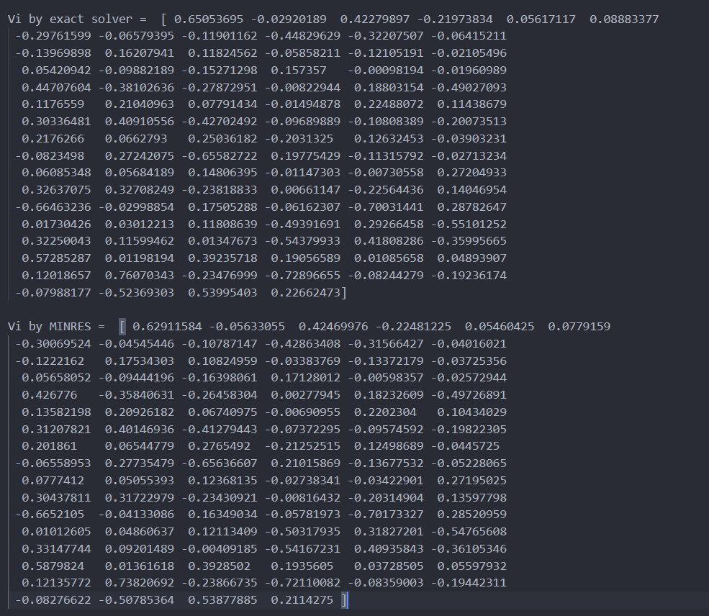

Now, we subtract Vi(MINRES) from Vi(exact)

